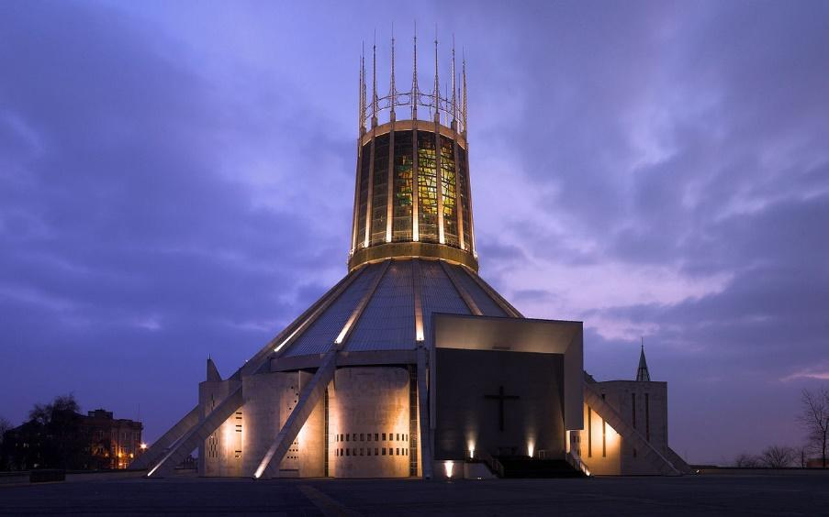 | Society for Church Archaeology Annual Conference 2023  16th – 17th September 2023  The Church in North West Britain and its Connections

Liverpool Metropolitan Cathedral
Saturday 16th September 2023
Norton Priory Fieldtrip on Sunday 17th September 2023
Hosted in partnership with the University of Liverpool and sponsored by the Liverpool Centre for Medieval and Renaissance Studies (LCMRS)
The Society for Church Archaeology is pleased to announce its annual conference for 2023, on the theme of 'The Church in North West Britain and its Connections’. Covering the north-western seaboard of England, Scotland, and Wales, this region has a long and complex history of church and ecclesiastical sites which do not always or easily mirror the changes and continuities noted in other, arguably more well-researched and well-excavated areas, of Britain and Ireland. Reflecting centuries of cultural exchange around the Irish Sea, not least with western Ireland, the North West has its own rich heritage, combining influences from the south-west of Britain, Ireland, and Scandinavia. From its earliest medieval origins to its most recent church heritage, this conference aims to include the widest range of periods and places, connections or isolations, from this complex and vibrant region.
Our keynote will be presented by Professor Harold Mytum (University of Liverpool) with a wine reception sponsored by LCMRS on Saturday 16th September at Liverpool Metropolitan Cathedral (please note the date and venue change).
Our fieldtrip will be a coach trip to Norton Priory on Sunday 17th September. Price includes entry fee, a seat on the coach, and catered lunch: https://www.nortonpriory.org/ Professor Mytum, who has led excavations at the priory for several seasons, will also give a private guided tour of the site and Professor Jill Rudd (English, University of Liverpool) will host an optional special interactive reading and discussion on the Old English poem The Ruin in the priory grounds.
For enquiries about the conference and bookings: scaconference2023@outlook.com
Conference programme and booking form: www.churcharchaeology.org/current-conference
Saturday 16th September 2023: SCA Annual Conference and AGM
The Gibberd Room, Liverpool Metropolitan Cathedral (UK)
9:30-10:00 | Registration
10:00-10:15 | Welcome
10:15-10:30 | Ken Murphy (Dyfed Archaeology) “St Patrick's Chapel at St David’s, Wales”  Dyfed Archaeological Trust’s and the University of Sheffield’s excavations in 2014-16 and 2019 and 2021 at St Patrick’s Chapel revealed deeply stratified deposits in wind-blown sand, beginning in the mid-eighth century and continuing into the sixteenth century. The site is threatened by coastal erosion. The earliest recognised element, dating to the mid-eighth century, was an oval stone-built enclosure with a centrally place rectangular structure built from shale slabs. Several of the slabs were carved — a ring-cross with interlace design, a human figure dressed in a tunic with arms raised, and most intriguingly an inscription reading ‘donoec’ (an Irish compound name meaning something like ‘dark youth’ or ‘noble warrior’) next to an image of a boat and possibly a wave. Provisional interpretations of this structure include a memorial, cenotaph, altar and praying station. It closest parallels are Irish leachta. The enclosure and structure were rapidly covered by wind-blown sand. A substantial walled cemetery enclosure was constructed over these early features and the first burials were placed in the ground. These were exclusively of infants and foetuses. Sand continued to accumulate, and as it did so more burials were put in the ground. Over 250 burials were excavated, stacked up to eight deep in the sand, between the late eighth/ninth century and c. 1100. After the first phase of child burial, both children and adults were buried. In the eleventh/twelfth century a stone-built chapel (St Patrick’s) was constructed on top of the early medieval cemetery. Burials associated with the early use of the chapel were once again exclusively children. The chapel was repaired and modified during its use, before being abandoned during the sixteenth century. Ancient Connections, an EU-funded Wales/Ireland project, and Cadw funded the excavation with additional monies from the Pembrokeshire Coast National Park Authority and The Nineveh Trust.
10:30-10:45 | Glenn Cahilly-Bretzin (University of Liverpool) and Tom Livingstone (Chester Cathedral) “The Repurposing of Werburgh's Remains and Shrine, Chester Cathedral”  This paper will explore the appropriation of Saint Werburgh’s remains and the physical development of her shrine at Chester Cathedral from the Norman period to today. We will begin with a discussion of the convent in Hanbury’s promotion of Werburgh’s cult through exhumation and a supposed theft followed by Æthelflæd later translation of the saintly remains to Chester as part of her refounding of the city as a Mercian royal stronghold on the Welsh border. This will then lead to a analysis of the various shrines built to hold Werburgh’s remains in Chester as well as their placement in the Abbey and later Cathedral. The building developments shall be placed in historical context to explore how the remains or shrine were variously used by subsequent custodians in respond to the needs of that time.
10:45-11:00 | Kevin Cootes (Liverpool John Moores University) “The Archaeology of Grief. Deviations in Burial Practice in a Later Medieval Graveyard in Poulton, Cheshire.”  The Poulton Research Project was established in 1995 with the initial aim of identifying the location of a lost Cistercian Abbey. Continual research in this small Cheshire village has revealed an extensive multi-period archaeological landscape, including a small medieval chapel and secular graveyard. To date, a minimum of 807 individuals have been excavated, comprising the remains of the farming community who worked the land for the monks after they relocated to Dieulacres (Staffs) in the 13th century. The burials are typical for the Later Medieval Period, being interred in shallow graves on an east-west orientation without burial markers or grave goods. Analysis has revealed, however, that within this general uniformity there is significant but subtle variation within bodily positioning. This paper attempts to identify patterns in these variations which may represent personalisation of individual burials. Further, this individualisation may represent a range of emotions (especially grief) felt by mourners who would have been responsible for burying their family members.
11:00-11:15 | 15 min Q&A with the speakers
11:15-12:00 | Refreshments Break
12:00-12:15 | Stephen Henders (Independent Researcher) “Hagioscopes and their significance for medieval worship, with reference to examples in NW England”  This is a study of hagioscopes in northern England, referencing a medieval church in south west Lancashire where there are nine examples within the building including a triple hagioscope. This is a unique feature in a medieval church in England. The church has this fabric created for use of the Sarum rite. The Lateran council of 1215 put the emphasis on the sacrificial aspect of the mass and Transubstantiation of the elements of bread and wine. For the ordinary worshipper the practice of seeing the sacrament of communion was all important, surpassed only by the devotions at Eastertide which culminated in physically receiving the sacrament on Easter Sunday. The ritual of vigil during Holy Week reveals the importance of the Hagioscopes and their connection to the Easter Sepulchre. and ritual devotion. Halsall church, built in the century following the Lateran Council is curious in that the Hagioscopes while permitting views of the sacred, also served to control and spy on the village worshippers and to ensure the social pecking order and due reverence was observed In this way behaviour was controlled, this was important in the time following the Black Death, a time of skill shortages when workers and survivors of the pandemic were conscious of their own importance.
12:15-12:30 | Joanne Machin (UHI Archaeology Institute, Orkney) “Medieval maritime pilgrimage - myth or maxim? Building the evidence”  During the early medieval period, as Christianity spread and saints and shrines were established, history documents how pilgrims, seeking the salvation of their souls, endured hardship and challenge as part of the pilgrimage process. This research explores the potential for maritime pilgrimage across the Irish Seaboard, analysing the Irish Sea corridor as a pilgrimage highway to the surrounding landscape, examining links to ecclesiastical settlements and social and cultural contact and exchange. The historical archaeology framework includes an initial case study across Galloway in southwest Scotland of ecclesiastical and secular sites, including landing sites. The research demonstrates the importance of the links between the two, particularly their actual placement within the land and seascape. This interdisciplinary research has combined experimental phenomenological archaeology techniques featuring seascape work, landscape archaeology and filming by drone, as well as the study of traditional historical documents, cartography and placenames. This paper outlines this research and summarises the early findings. It will be in three parts. The first will outline the significant ecclesiastical links within the landscape and the archaeology that makes this case study area so important. The second will give the context of the multidisciplinary methodology and challenges faced. The third will outline the early results of this research through a seascape and maritime cultural dynamic. This element proffers that ecclesiastical monumentality placement within the landscape was dictated by the secular landing sites to which they were linked and reliant during the early medieval period and discusses how this impacts maritime pilgrimage.
12:30-12:45 | Ian Faulds (University of Huddersfield) “Ancient parish church in the Isle of Man (Kirk Maughold): A forgotten pilgrimage centre”  This paper explores the pivotal regional role of an ancient parish church in the Isle of Man. Like other early Irish Sea Christian foundations (Whithorn, Iona, Lismore), Kirk Maughold owes its existence to the arrival of a fifth century missionary saint, whose story includes miracles, healing and both local and ‘international’ pilgrimage. The texts that tell us about St Maughold, Machaldus or Magail, beginning in c.690, are written largely in Latin, with late mediaeval contributions in both English and Manx, indicating not only an unusually large community or settlement (magna civitas Magail) but also a resident bishop and multiple priests. Probably functioning as a cathedral or ‘mother church’ (Moir Agglish Mannin) by the twelfth century, Kirk Maughold is unique on the Island in having a Perpendicular East window, evidence of mediaeval stained glass and the remains of carved capitals, dogtooth ornamentation and moulded columns, maybe even a shrine, probably all funded by pilgrim offerings. Development and pilgrimage unaccountably cease around the fourteenth century, possibly the result of shrine rivalry, politics and ecclesiastical reform – but the church is now recreating its mediaeval past and looking ahead with a Pilgrim Way and traditional pilgrim badge.
12:45-1:00 | 15 min Q&A with the speakers
1:00-2:00 | LUNCH
2:00-2:45 | AGM
2:45-3:00 | Rachel Newman (Oxford Archaeology) “The Monastic site of Dacre” [abstract TBC]
3:00-3:15 | Emily Bowyer-Kazadi (University of Liverpool) “Deconstructed Landscape Photography: A Framework for Engaging with Church Archaeology in NW Britain”  This paper is based on and developed from a talk given to the Society for Church Archaeology in November 2022 titled ‘Deconstructing All Saints’ Church in Bakewell, Derbyshire’. It shall explore how the use of deconstructed landscape photography can be used to engage with church archaeology and will provide a framework for use by different stakeholders. Several churches within North West Britain shall be looked at in order to formulate this framework in which deconstructed landscape photography can be used to improve engagement with church archaeology. Looking at North West Britain shall provide a different scope to the PhD research which focused on the context of British national parks. The paper will investigate the different ways that deconstructed landscape photography can be used such as guided photography sessions, talks, and exhibitions/displays. These shall then be set out in a framework which will provide guidelines on technical elements (photographic techniques and using the software needed) as well as looking at issues on how this form of engagement can impact people’s wellbeing and identity and access to church archaeology.
3:15-4:00 | Morn Capper (University of Chester) and Rachael Abbiss (Churches Conservation Trust).“St Mary’s, Shrewsbury: Preserving an Historic Assemblage in the 21st Century”  The Norman and Gothic Church of St Mary’s, Shrewsbury possesses one of the finest collections of stained glass in western Britain. Yet this impressive Grade I listed building created by prominent royal and local sponsorship in the Middle Ages, has an older Anglo-Saxon foundation, while the glass also reflects a pan European assemblage of the eighteenth and nineteenth century. The medieval historic glass, probably acquired from several local Shrewsbury churches, was installed and restored by David Evans, alongside a range of historic glass collected from the Continent by the Revd. William Gorsuch Rowland, including from Altenberg Abbey and the Cathedral of Trier. Under threat from a dwindling congregation in 1980s this unique assemblage was rescued by the Churches Conservation Trust only to face vandalism during Covid 19 Lockdown in 2019, which damaged a Belgian glass depicting the Adoration of the Magi. This paper explores the history of the building and associated collections as a Medieval and nineteenth-century assemblage and discusses the agents of deterioration that have threatened the assemblage as an urban church. Most importantly this paper emphasises positive responses to the risks faced by this historic church building as an example of urban heritage crime, demonstrating how new interpretation, social and community connections, will play a vital role in 21st century heritage preservation.
4:00-4:30 | 15 min Q&A with the speakers (plus closing remarks)
4:30pm | Conference ends
5:30-6:45pm | Wine Reception and Keynote: Professor Harold Mytum (The Gibberd Room)
7:00pm | Conference Dinner

Sunday 17th September 2023: Norton Priory Fieldtrip
9:45am | Meet at coach pick-up point for 10:00am departure
11:00 -4:00pm | Tour of the Priory Grounds and excavations by Prof. Harold Mytum (University of Liverpool); the Old English elegy ‘The Ruin’ by Prof. Jill Rudd (University of Liverpool); free time at Priory and Museum.
4:00pm | Depart Norton Priory, ETA in Liverpool 4:45pm.

To make a booking:
- Our preferred booking method is through Eventbrite. We can accept online payments and cheques through our Eventbrite page or visit https://www.churcharchaeology.org/current-conference
- However, if you are unable to book via Eventbrite AND you are paying by cheque, you may use the printed booking form below. We are unable to accept online payments via the printed booking form. Please use our Eventbrite booking form for online payments.
- Eventbrite online payments (not inc. cheques) will close by Friday 1 September 2023.
- All cheque payments (Eventbrite and printed booking) need to be received by Friday 18 August 2023. You can notify scaconference2023@outlook.com to expect a printed booking if you wish, but we cannot confirm your place(s) until we have received the form and cheque.
- Booking will close earlier if all places have been allocated prior to the aforementioned dates.
- Bookings are registered on a first-come, first-served basis.
**PLEASE ONLY COMPLETE THIS BOOKING FORM IF YOU CANNOT USE EVENTBRITE AND YOU ARE PAYING BY CHEQUE**
Your booking will only be registered once the form has been received by the SCA Treasurer. You will be notified via email with booking confirmation (please include an email in the box below)
Event | Price | Quantity
Annual Conference + AGM inc. lunch (members) | £25.00
Annual Conference + AGM inc. lunch (non-members) | £54.50
Keynote and Wine Reception (limited spaces; please reserve) | Free
Conference Dinner (limited spaces; please reserve) Pay at venue. | n/a
Norton Priory (inc. seat on the coach and lunch; limited spaces) | £12.50
TOTAL TO PAY
Name(s) of attendees:

Please list any dietary requirements:

Contact email address (so we can confirm your booking):

If you have not already joined, would you like to be added to the Society’s email list?
Yes |  |  | No
You can unsubscribe at any time by emailing churcharchaeology@gmail.com
Our GDPR statement is available on our website or directly here: www.churcharchaeology.org/_files/ugd/c2a215_0a9856bb03714c0faccf693af7e15876.pdf
Please make cheques payable to: The Society for Church Archaeology
Please print and post your completed booking form with (a) your cheque (b) the name(s) of attendees being paid for (c) a return postal address to:
Treasurer SCA, Pandy Treban, Bryngwran, Holyhead, Anglesey, LL65 3YW

Please be aware that your booking will not be confirmed until the cheque has been received (and then a follow-up email is sent by us confirming receipt once it arrives).

